1. **Hello World RESTful Web Service**

HelloController.java

package com.cognizant.spring_learn.controller;

import org.springframework.web.bind.annotation.GetMapping;

import org.springframework.web.bind.annotation.RestController;

*@RestController*

public class HelloController {

*@GetMapping*("/hello")

public String sayHello() {

return "Hello World";

}

}

application.properties

spring.application.name=spring-learn

server.port=8083

SpringLearnApplication.java

package com.cognizant.spring_learn;

import org.springframework.boot.SpringApplication;

import org.springframework.boot.autoconfigure.SpringBootApplication;

*@SpringBootApplication*

public class SpringLearnApplication {

public static void main(String[] args) {

SpringApplication.*run*(SpringLearnApplication.class, args);

}

}

**Output:**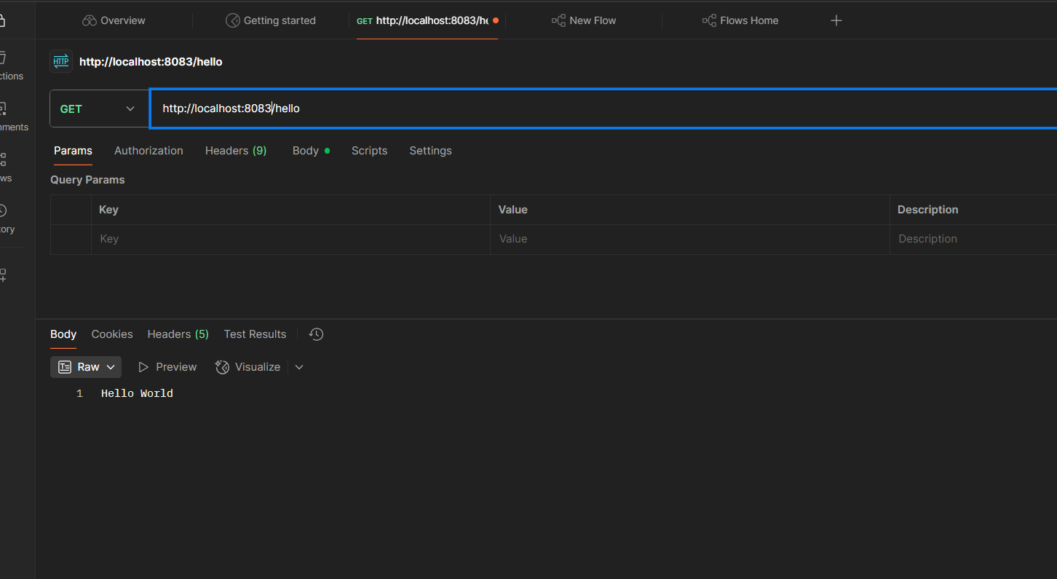

1. **REST - Country Web Service**

country.xml

<?xml version="1.0" encoding="UTF-8"?>

<beans xmlns="http://www.springframework.org/schema/beans"

xmlns:xsi="http://www.w3.org/2001/XMLSchema-instance"

xmlns:util="http://www.springframework.org/schema/util"

xsi:schemaLocation="http://www.springframework.org/schema/beans

http://www.springframework.org/schema/beans/spring-beans.xsd

http://www.springframework.org/schema/util

http://www.springframework.org/schema/util/spring-util.xsd">

<bean id="country" class="com.cognizant.spring_learn.Country">

<property name="code" value="IN"/>

<property name="name" value="India"/>

</bean>

</beans>

CountryController.java

package com.cognizant.spring_learn.controller;

import org.springframework.context.support.ClassPathXmlApplicationContext;

import org.springframework.web.bind.annotation.GetMapping;

import org.springframework.web.bind.annotation.RestController;

import org.springframework.context.ApplicationContext;

import com.cognizant.spring_learn.Country;

*@RestController*

public class CountryController {

ApplicationContext context=null;

*@GetMapping*("/country")

public Country getCountry() {

// Load the bean from XML on every request (or you could cache it)

if(context==null)

context = new ClassPathXmlApplicationContext("country.xml");

Country country = context.getBean("country", Country.class);

return country;

}

}

**Output:** 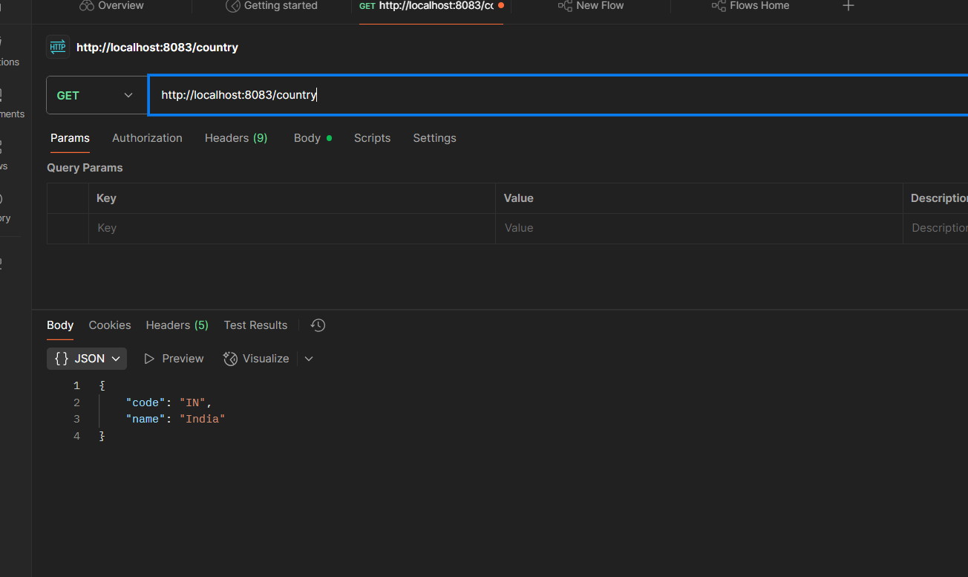

1. **REST - Get country based on country code**

**code:**

country.xml

<?xml version="1.0" encoding="UTF-8"?>

<beans xmlns="http://www.springframework.org/schema/beans"

xmlns:xsi="http://www.w3.org/2001/XMLSchema-instance"

xmlns:util="http://www.springframework.org/schema/util"

xsi:schemaLocation="http://www.springframework.org/schema/beans

http://www.springframework.org/schema/beans/spring-beans.xsd

http://www.springframework.org/schema/util

http://www.springframework.org/schema/util/spring-util.xsd">

<bean id="country" class="com.cognizant.spring_learn.Country">

<property name="code" value="IN"/>

<property name="name" value="India"/>

</bean>

<!-- List of countries -->

<util:list id="countryList">

<bean class="com.cognizant.spring_learn.Country">

<property name="code" value="IN"/>

<property name="name" value="India"/>

</bean>

<bean class="com.cognizant.spring_learn.Country">

<property name="code" value="US"/>

<property name="name" value="United States"/>

</bean>

<bean class="com.cognizant.spring_learn.Country">

<property name="code" value="JP"/>

<property name="name" value="Japan"/>

</bean>

<bean class="com.cognizant.spring_learn.Country">

<property name="code" value="DE"/>

<property name="name" value="Germany"/>

</bean>

</util:list>

</beans>

CountryController.java

package com.cognizant.spring_learn.controller;

import org.springframework.context.support.ClassPathXmlApplicationContext;

import org.springframework.http.HttpStatus;

import org.springframework.web.bind.annotation.GetMapping;

import org.springframework.web.bind.annotation.PathVariable;

import org.springframework.web.bind.annotation.RequestMapping;

import org.springframework.web.bind.annotation.RestController;

import org.springframework.web.server.ResponseStatusException;

import java.util.List;

import org.springframework.context.ApplicationContext;

import com.cognizant.spring_learn.Country;

*@RestController*

*@RequestMapping*("/countries")

public class CountryController {

ApplicationContext context=null;

// GET /countries/{code}

*@GetMapping*("/{code}")

public Country getCountryByCode(*@PathVariable* String code) {

// Load the bean from XML on every request (or you could cache it)

if(context==null)

context = new ClassPathXmlApplicationContext("country.xml");

List<Country> countries = (List<Country>) context.getBean("countryList");

return countries.stream()

.filter(c -> c.getCode().equalsIgnoreCase(code))

.findFirst()

.orElseThrow(() ->

new ResponseStatusException(*HttpStatus*.***NOT_FOUND***, "Country not found"));

}

}

